Segmentation of credit card customers

Objective Defining the segments of customers to help make business strategy for marketting.

Business Problem

- Derive KPIs
- Get insights on customer profile
- Clustering
- Profiling
- Strategic insights for marketting

Data Availability

- Customer level credit usage behavioral features were given for the time period of 6 months for 9000 customers.

Approach:

1 Importing the dataset
2 Data Audits

- check for duplicate rows
- check for missing values
- check for outliers

3 Preliminary data preparation

- Missing Imputation
The missing values in the data were imputed with median value of the respective features.
- Outlier capping
The Outliers were present in the columns like purchases, payments which were then capped with the 1% and 99% percentile values

4 Identifying the key performance indicators

Based on the customer data provided some of the KPIs were derived,

- Monthly average purchase
Monthly_avg_purchase = PURCHASES / TENURE

- Monthly cash advance
Monthly_cash_advance = CASH_ADVANCE / TENURE

- Average amount per purchase transaction
PURCHASES_TRX - given in the dataset

- Average amount per cash-advance transaction
CASH_ADVANCE_TRX - given in the dataset

- Limit of usage
limit_usage =BALANCE / CREDIT_LIMIT

- Purchase types
None, One-off, Installment, Both

Insights derived from observing and visualising the above KPIs,

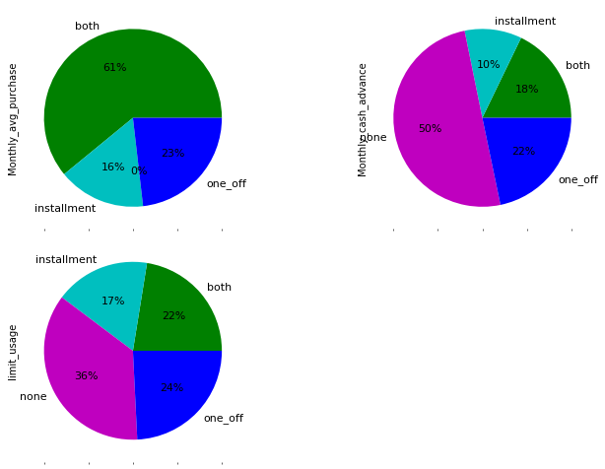
From the above plots the following insights are found,
- Monthly average purchase
High → both, Low → none
- Monthly cash advance
High → none, Low → installment
- Limit of usage
High → none, Low → installment
5 Feature Reduction

- PCA (Principal Component Analysis)

By PCA, 8 PCs were able to explain 80% of the variance of all Xs. Factor loading matrix was created with those 8
PCs and the variables having high correlation with each PCs were selected.

selected_vars_pca = ['BALANCE','BALANCE_FREQUENCY','CASH_ADVANCE','CASH_ADVANCE_FREQUENCY', 'CASH_ADVANCE_TRX', 'CREDIT_LIMIT','INSTALLMENTS_PURCHASES','MINIMUM_PAYMENTS']

The above features were able to explain the maximum variance in the data.

6 Finding Optimum #Clusters

- Elbow method (wcss)

Within Cluster Sum of Squares – minimum value of wcss will result in maximizing the distance between the clusters.

The Elbow plot was created for the range of 1 to 10 number of Clusters,
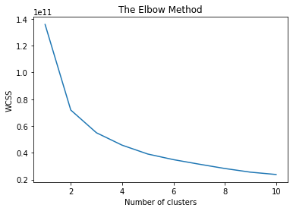
From the above plot it is found that 3 cluster solution was the Optimum as the graph showing a sudden decrease around the 3 cluster point.

- Silhouette analysis

The Silhouette score was calculated for the range of 2 to 10 number of clusters,

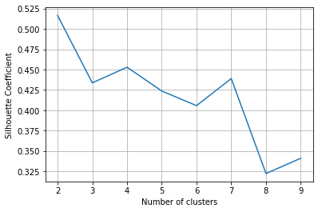
The Silhouette value is high for the #3, #4 and #7 cases.
From the above two methods,
It is found that the data can be well segmented if the number of clusters is either 3 or 4.

7 Model Implementation

- K Means clustering
The K Means was applied on the data for 3, 4 and 7 number of Clusters as identified from the above plots.
8 Profiling

The Profiling was done for the 3, 4 and 7 Cluster models outputs
The clusters were grouped and the mean of the other features were taken to create the profile out.

The values for each feature less than 0.8 times their overall mean was highlighted by red,
The values for each feature greater than 1.2 times their overall mean was highlighted by green.
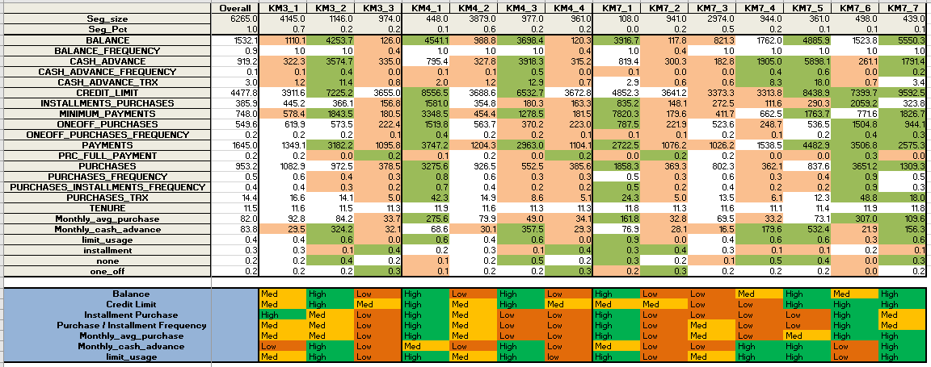

9 Insights and marketting strategy

3 #Clusters

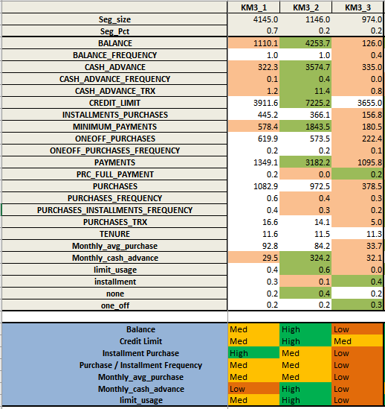

Target - marketting strategy required
Good - may be different schemes increase purchase even more
Risky - less marketting required
Insights and type of marketting strategy
Cluster 1: Spender - Good
Cluster 2: Passive - Target
Cluster 3: Spends more with low balance – Good

4 #Clusters

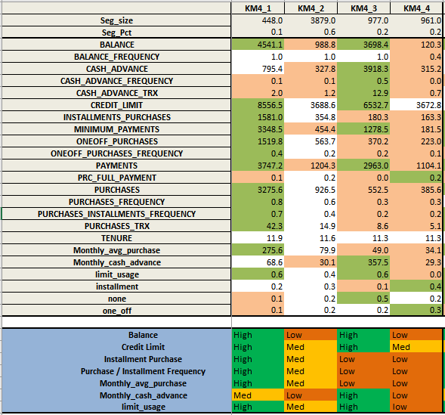

Target - marketting strategy required
Good - may be different schemes increase purchase even more
Risky - less marketting required

Insights and type of marketting strategy
Cluster 1: Spender - Good
Cluster 2: Spender - Good
Cluster 3: Passive - Target
Clsuter 4: Retiring - Risky

----------------------------------------------------------------------------------------------------------------------------------------------------------------

7 #Clusters

